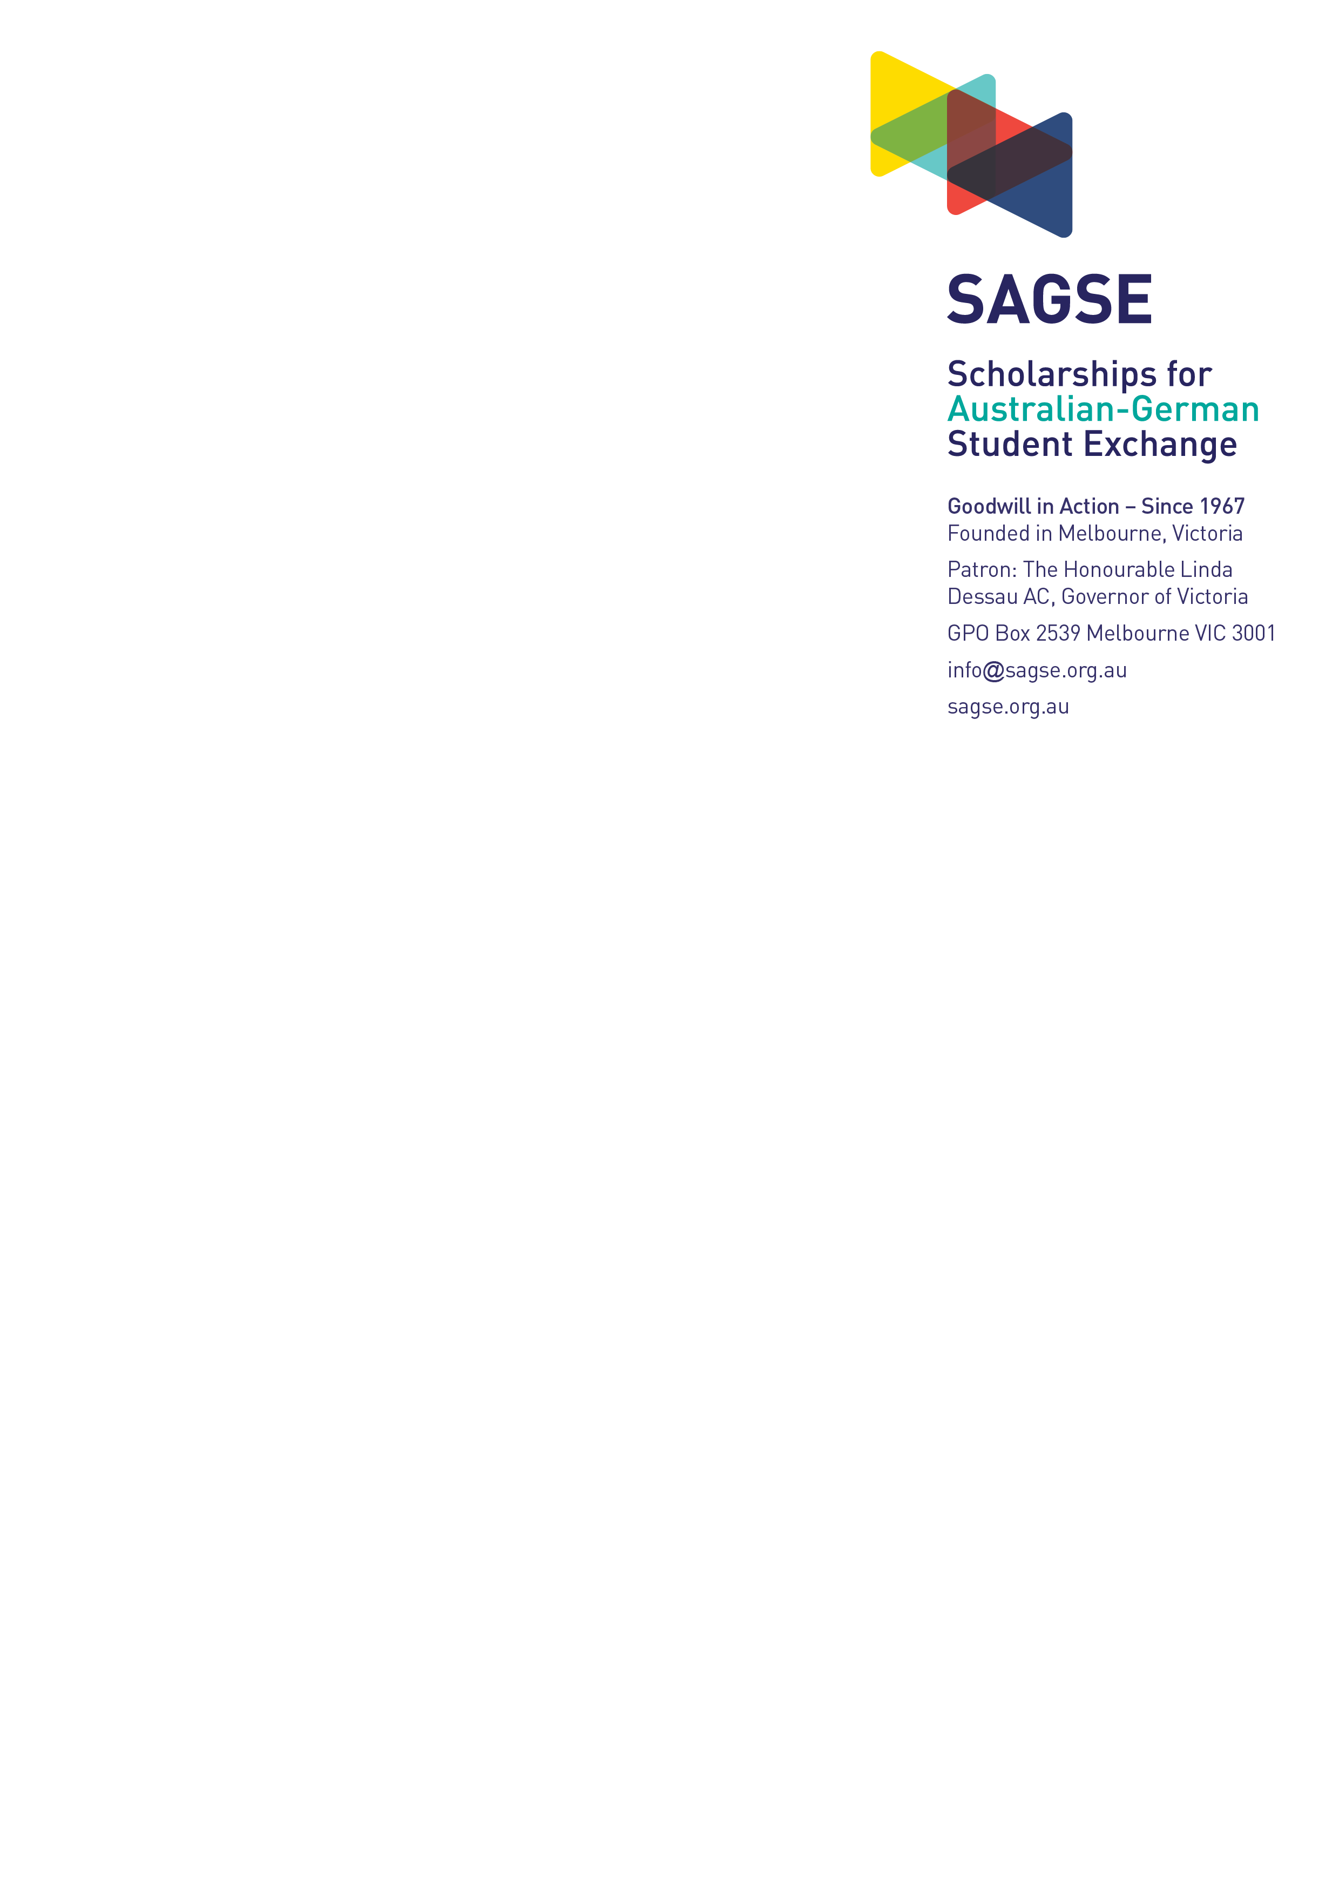

**A.**

**Parental / Guardian Consent Form**

**Please note:**

*Applications without signed consent CANNOT be considered.*

*As*

*you will be submitting an online application, you are required to print, have*

*this form completed and signed before submitting a scan as an attachment to*

*your application.*

**I consent to my son/daughter participating in an exchange program to**

**Germany if he/she is successful in winning a scholarship.**

**I agree that my son / daughter will meet all COVID-19 vaccination and**

**health requirements in sending and receiving students from Australia to**

**Germany and vice versa.**

**I understand that SAGSE retains the capacity to cancel its exchange**

**program due to operational circumstances or the regulator or health**

**authorities in either country restricting, suspending, or disallowing any**

**exchange or international travel.**

**I consent to SAGSE:**

•

**having responsibility for the student’s accommodation, support**

**and general welfare for the duration of the exchange program, and**

•

**having the authority to cancel the student’s exchange program and**

**arrange the prompt safe return of the student to Australia, due to:**

**1)**

**global, national or regional emergency circumstances**

**2)**

**Australian national, state or territory government directives**

**3)**

**the student’s physical or mental health circumstances, and/or**

**4)**

**the student’s serious breaches of the SAGSE code of conduct**

**5)**

**that require SAGSE to exercise its responsibilities for the**

[**student’s welfare**](https://www.sagse.org.au/scholarships)

[**.**](https://www.sagse.org.au/scholarships)

**Parent or Guardian signature/s:**

**___________________________ _____________________**

Print Name

Signature

**DATE ____________**

Please upload the completed form as part of your application at

https://www.sagse.org.au/scholarships

prior

to

**25th July 2025.**

***Applications without signed consent CANNOT be considered***

*.*